Review Sheet for Bio 230, Exam 3

- What is the general function of transcription factors in cells, and how do they accomplish this function?
Transcription factors are small proteins that bind to specific DNA sequences to facilitate or suppress transcription. They can accomplish this by interacting with other transcription machinery.

- Describe one example of negative control of gene expression.
The repressor in the lac operon or the tryptophan in the repressible operon exert negative control because they repress transcription. There are many other potential examples.

- In a repressible operon such as the regulation of tryptophan metabolism, how would you cause the repressor to inactivate?
Decrease the [corepressor].

- Every cell with a nucleus within a multicellular organism contains the same DNA within its nucleus. Describe how the major differences between cell types originate, meaning, how does the same genome lead to many different cell types?
The differentiation of eukaryotic cells is due to the differential expression of genes and their translated proteins at different times and in different combinations.

- Describe a technique that you would use to measure the mRNA that is expressed in a cell. One possibility is DNA microarrays. For these, mRNA extracted from cells are converted to cDNA by reverse transcriptase. The cDNA is then mixed with fluorescent probes that attach to one end of the cDNA. Often there is an amplification step to increase the number of copies (hopefully maintaining same proportions of copies) using the polymerase chain reaction (PCR). The cDNA mixture is then added to well of the DNA microarray (gene chip). Each well of the microarray contains a complementary DNA sequence for one gene. If that gene is present in the sample, it should bind in the well. Then unbound cDNA is washed away. The DNA microarray is imaged, and fluorescently labeled wells indicate that the gene in the well was present in the cDNA sample.

- Name one modification of histones and describe the histone code.
Histone tails can be methylated, acetylated or phosphorylated on their tails on specific amino acids. The histone code describes the series of modifications on histone tails that contribute to controlling whether DNA can be transcribed.

- What is DNA wrapped around histones called and what is its function?
  - It is called a nucleolus and it helps to initiate translation.
  - It is called a nucleolus and it helps to compact DNA.
  - It is called a nucleosome and it helps to initiate translation.
  - It is called a nucleosome and it helps to compact DNA.

- Which amino acids are coded for by the codons CAC AAG GGG, and how would they be affected by changes in the third positions of the codons?
His-Arg-Gly. Changing the first codon to CAA or CAG would change to glutamine, changing the second to AAU or AAC changes it to serine, and changing the nucleotide in the third position of the third codon has no effect (always codes for glycine).

- How will translation be affected if a cell is unable to synthesize or obtain methionine?
It will not be possible to initiate translation, since translated is initiated by formylated methionine (fMet) binding in the P site of the ribosome.

- After the initiation of translation, which site in the ribosome do charged tRNAs enter and bind? After the initial binding of methionine in the P site, all subsequent charged tRNAs bind in the A site.

- Name a post-transcriptional modification and state what role that it serves.
Addition of a 5’ methylguanosine cap or addition of a 3’ series of adenine (polyadenylation). Both stabilize the mRNA and prevent degradation.

- Why are immature mRNAs much longer than mature mRNAs?
They still contain intron (non-protein coding) segments.

- Where does RNA polymerase bind to initiate transcription in prokaryotes or eukaryotes?
The promoter sequence.

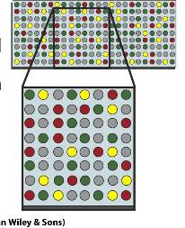
- In this picture of a DNA microarray (gene chip), why are some spots colored red, yellow or green, and others are colored gray? Assume that there were two cDNA samples that were tagged with red (Sample 1) and green (Sample 2) fluorescent probes, respectively. Then red spots indicate that a gene was expressed in sample 1 but not 2, green spots indicate that a gene was expressed in 2 but not 1, yellow indicates that a gene was expressed in both samples, and gray spots indicate a gene that was not expressed in either sample.

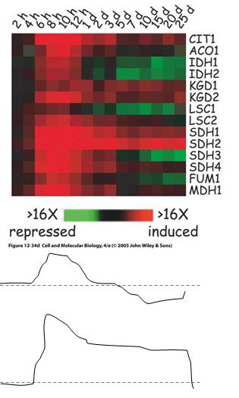
- The diagram to the right displays the time course of mRNA expression for genes in involved in the TCA cycle. Below that are two solid lines, with the dashed lines representing baseline gene expression, and upwards from that line is considered higher gene expression, with time along the x-axis the same as the top graph. Reading the graph to the right, which genes could give the gene expression profiles shown for the top solid line or the bottom solid line? You may use the 4 letter gene name for your answer (e.g. CIT1) Only one answer is sufficient for each, even if there is more than one potential answer. For the top one, in which expression increases and then decreases, SDH3 would be one example. For the bottom one that shows a sustained increase in expression, SDH2 is probably the best choice.

- What is the open reading frame and why is it important for gene and protein sequencing?

The open reading frame (ORF) refers to the start position on the mature mRNA that dictates how the codon triplets will be read to determine the amino acid sequence.

- What will be the consequence of inserting a uracil into the 6th position in the following sequence. Assume that you begin in the open reading frame. (A chart will be provided for the exam).
5’-GAG-CCC-AAA-CGC-3’ goes to 5’-GAG-CCU-CAA-ACG-C-3’ giving
Glu-Pro-Lys-Arg goes to Glu-Pro-Gln-Thr

- What is a consensus sequence?
This is a DNA promoter sequence whose position relative to the transcription start and whose sequence is largely conserved across species, such as the -10 sequence in bacteria or the TATA box in eukaryotes.

- What serves as the intermediate between mRNA and protein?
tRNA

- If the 3’ end of the tRNA has been cleaved, what part of translation will be affected?
The tRNA cannot be charged with an amino acid in this case.

- How many amino acids does each codon code for? Is the number of codons for each amino acid, larger, smaller or the same? 1. The code is redundant, so multiple codons code for many of the amino acids.

- What are the main steps in translation by the ribosome?
Small subunit binds mRNA
rRNA recognizes AUG on mRNA
tRNA-Met enters P site and binds to AUG
Large subunit binds (GTP)
Second tRNA binds A site (GTP)
Peptide bond (peptide attached to 2nd tRNA)
Translocation by 1 codon towards 3’ end (GTP)
Release of 1st tRNA from E site
Continue 5-8 until stop codon is reached
Stop codon in A site -> termination (GTP)

- A space probe brings back a new life form. It is carbon-based and its genetic material is similar to Earth DNA except that it uses 6 different nucleotide bases instead of 4. Its proteins are also similar to those on Earth, but there are 28 amino acids instead of 20. You hypothesize about the genetic code for this organism. How many "letters" would you propose in each codon of the genetic code for this organism? The code should be unambiguous and may be degenerate.
A minimum codon length of 2 would be appropriate, giving 6x6=36 codons, enough to be unambiguous and include start and stop codons. A longer codon would work, but it would be highly degenerate in that case, since a triplet length would give 216 codons.

- Which steps in translation require ATP hydrolysis? Which steps require GTP hydrolysis?
The only part of translation that requires ATP hydrolysis is charging the tRNA. The GTP requiring steps are listed in the answer to 22.

- Construct a genetic AND, OR, and NAND logic circuit.
For an AND, you want two components to come together to form a transcriptional activator. For an OR, you want two components that each individually are transcriptional activators and that don’t interfere with each other. For a NAND, you can have something similar to the repressible operon, using a corepressor. When either component of the corepressor is present/active by itself, transcription will not be affected. It is only when the two components come together to form an active repressor that transcription will be blocked.

- In the inducible operon, what would be an example of positive control? Of negative control? Which components would constitute an AND circuit?
cAMP or cAMP-cRP is a form of positive control. Glucose and lactase (because it breaks down the inducer lactose) are forms of negative control. cAMP and lactose together form an AND circuit for induction of transcription here.

- In the repressible operon, what would be an example of negative control? Which components would constitute a NAND circuit?
Tryptophan is an example of negative control, and as mentioned above, the corepressor can be considered a NAND circuit.

- Describe how a DNA microarray works.
Complementarity between DNA and see answer to 5.

- Which histone modifications permit or repress transcription and where on the histone are the modifications made?
Acetylation permits transcription while methylation and deacetylation represses transcription. Modifications are made on the histone tails.

- What types of DNA represented by the highly repeated, moderately repeated and non-repeated fractions of eukaryotic DNA?
Satellite DNA for highly repeated DNA, DNA for ribosomal proteins and genes and histones for moderately repeated DNA and unique protein coding regions for non-repeated DNA.

- If the β-clamp of the replisome is damaged, will the leading strand or lagging strand, both or neither be affected and why?
Both will be affected, since the β-clamp of the replisome holds the DNA polymerase onto the DNA. If the gamma clamp had been affected, both leading and lagging strands would be affected, but the lagging strand would be affected more, because the gamma clamp loader must reload the beta clamp many times for the lagging strand.

- What process would be affected by alteration of the sigma factor?

Transcription initiation.

- Draw and label the key components of replication on the leading and lagging strands.
DNA polymerase III and DNA polymerase I should also be shown here. DNA polymerase 1 will be in the vicinity of the primer. Also, ligase should be shown.
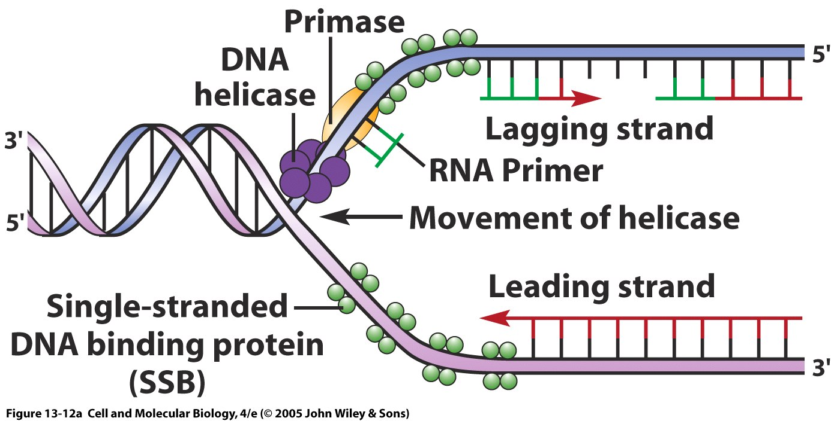

Below is not necessarily what I was looking for, but this would have been acceptable also.

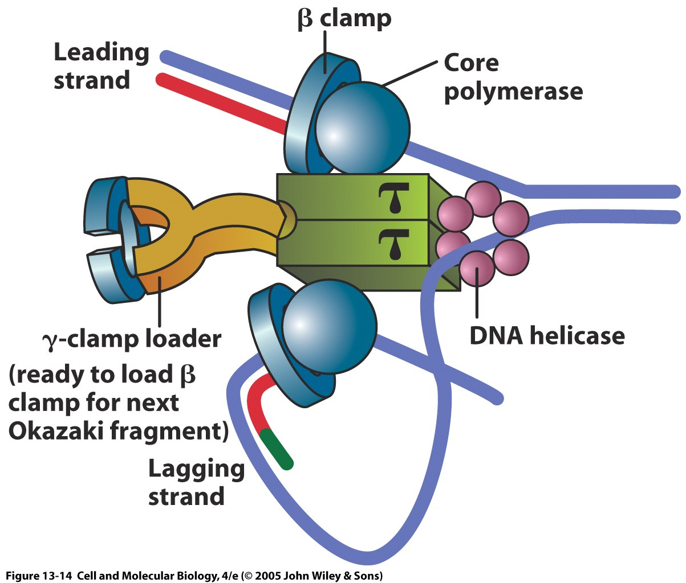

- Which components are found in both DNA replication and DNA repair?

Helicase, ligase, could also say DNA polymerase I

- During replication, which strand would contain more RNA and why?
The lagging strand would contain more RNA because it has more primers on it.

